Project Report
___________________________________________________

Data structures
(DICTIONARY)

Submitted to:
Sir Hanan Farooq

Submitted by:
Aneela Bashir (22F-3414)
Eman Fatima (22F-3343)

Deadline
9 - 12 - 2023

Dictionary (Data structures final project )

Introduction:

Our project is about dictionary . Which contain a great number of words along with their meaning .The dictionary txt file have been provided .

Chaining Hashing :

In this project we have used chaining hashing . The whole dictionary has been loaded by chaining hashing .
Chaining is a technique used for avoiding collisions in hash tables. A collision occurs when two keys are hashed to the same index in a hash table. Collisions are a problem because every slot in a hash table is supposed to store a single element. Chaining hashing ends up collision by making linked list . It make it fast to access any element

We have implemented 6 functions

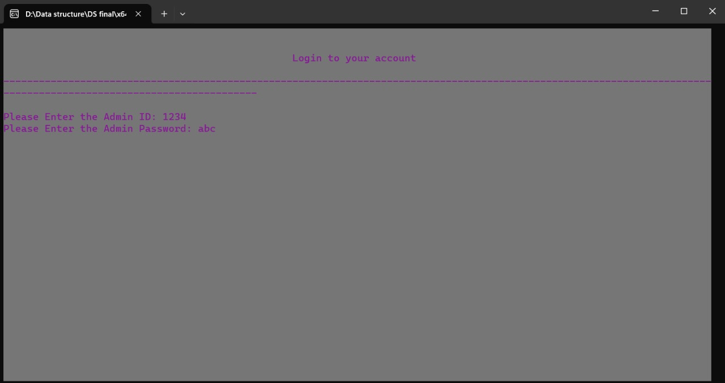

Load Dictionary:
In this function we load the whole words with their meanings from dictionary txt file to hashing chaining .

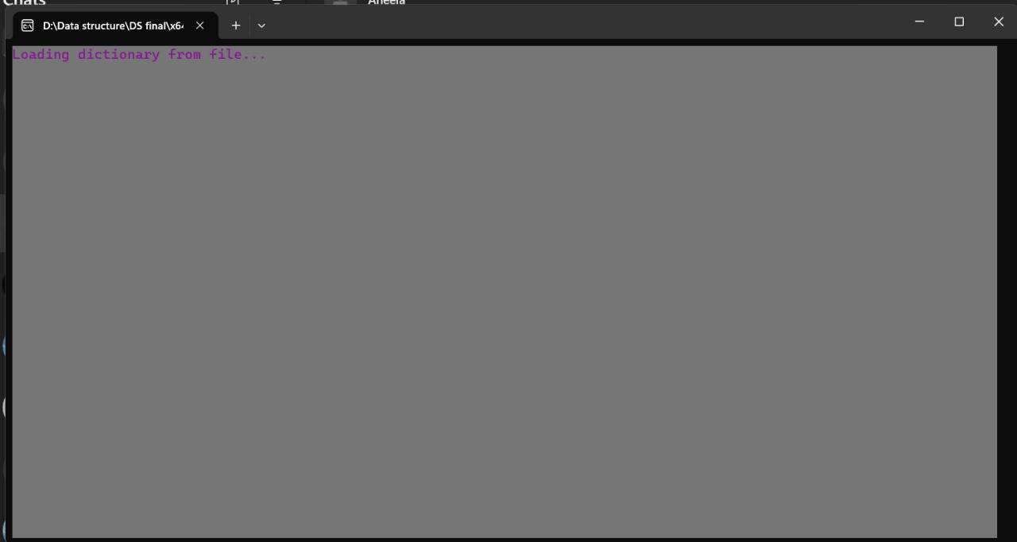

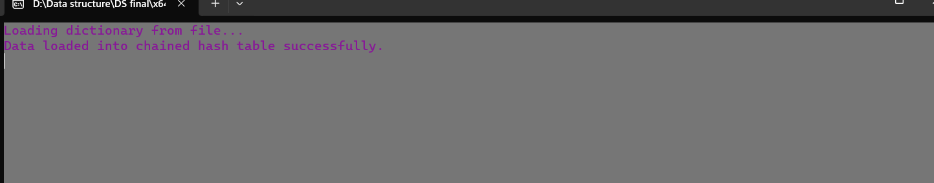

Insert Word :
In this function we are inserting a word entered by user in file using hashing chaining. Firstly we search the word entered by user is either present in file or not . If it is already present then a message prints that “word already present” .Then the suitable place is being searched for the new word. The word in being added in its
correct place for example if user added “abc”, then it is being added in dictionary after ending of word “ab” .
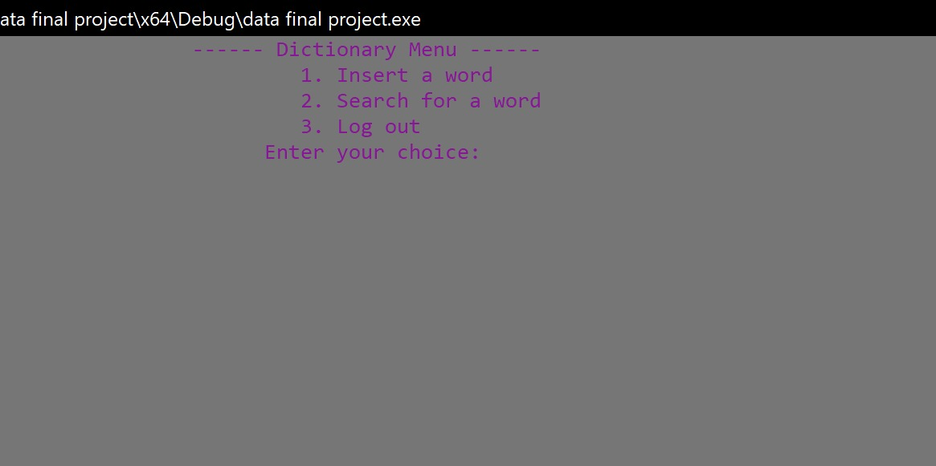

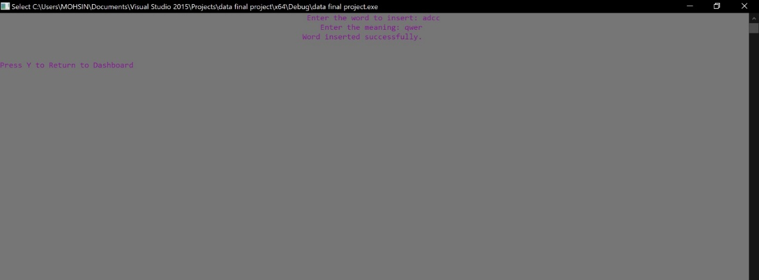

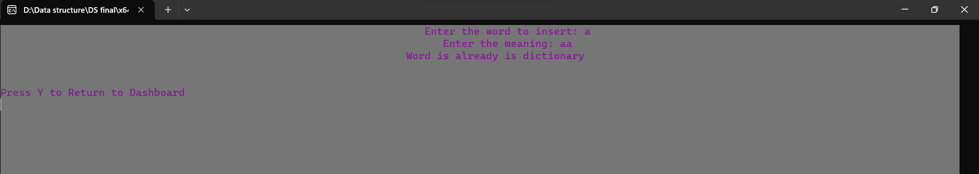

Search Word:
This function is searching the word from Dictionary txt file if it is present then the meaning of this word is being displayed on screen . And if it is not found then it is simply displaying a message that “word not found”.

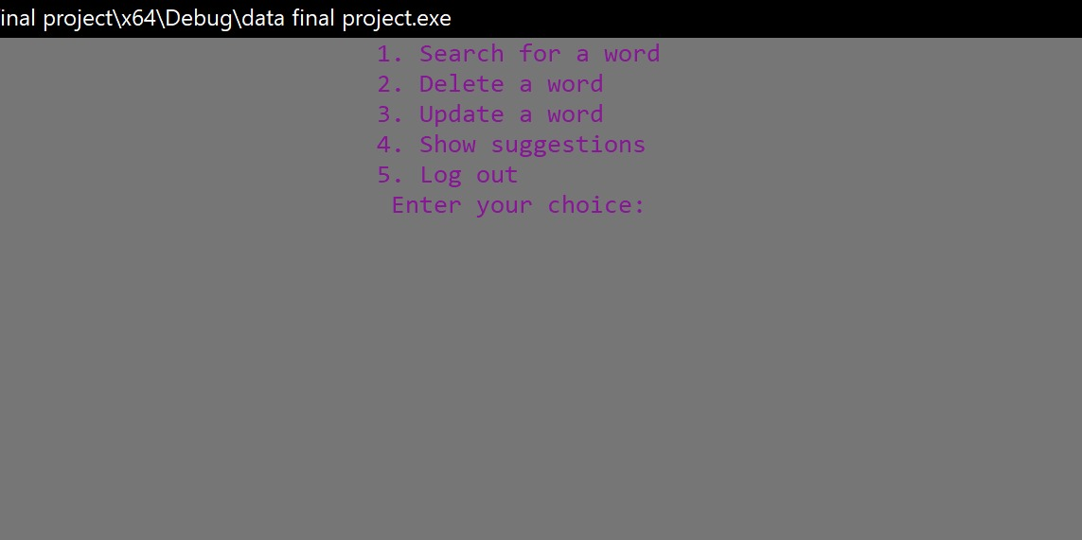

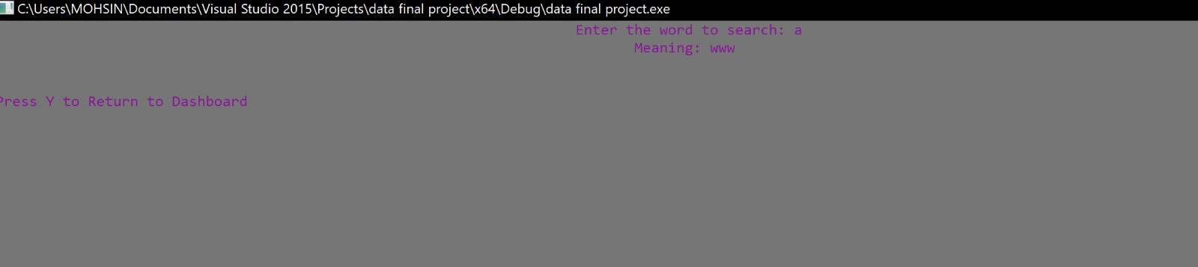

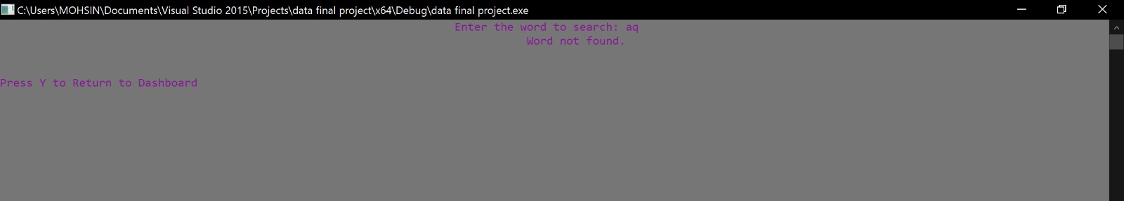

Delete Word:
In this function we are deleting word entered by user from txt file using hashing chaining and rearranging the whole remaining words in hash table.Firstly it is being searched if it is present in the dictionary then deleted otherwise a message is being printing on screen that “word not found” .

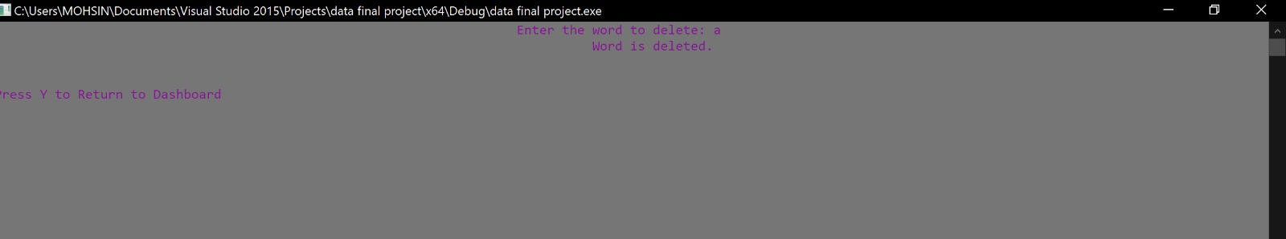

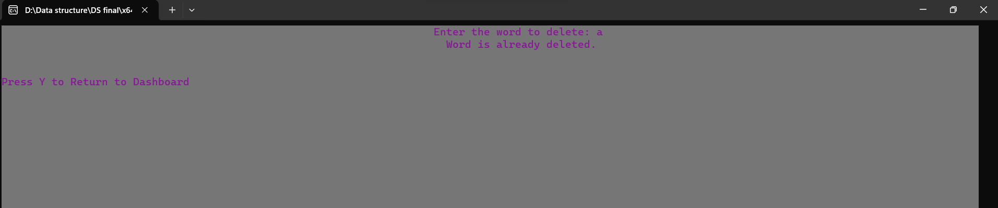
Suggestions :
This function is showing top 10 suggestions on entering any alphabet or word of any length by user . Firstly it is calculating the length of entered word and then searching it from the dictionary file and showing top ten words next of that word .

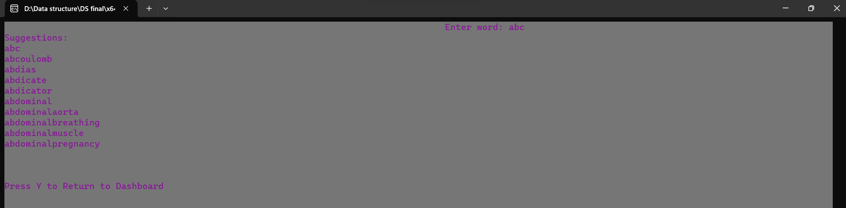
Update Word:
In this function a word is being updated that is being entered by user . Firstly it is being searched if it is present in the dictionary then its meaning is being replaced by new one . Otherwise a message is printing that “word not found”.

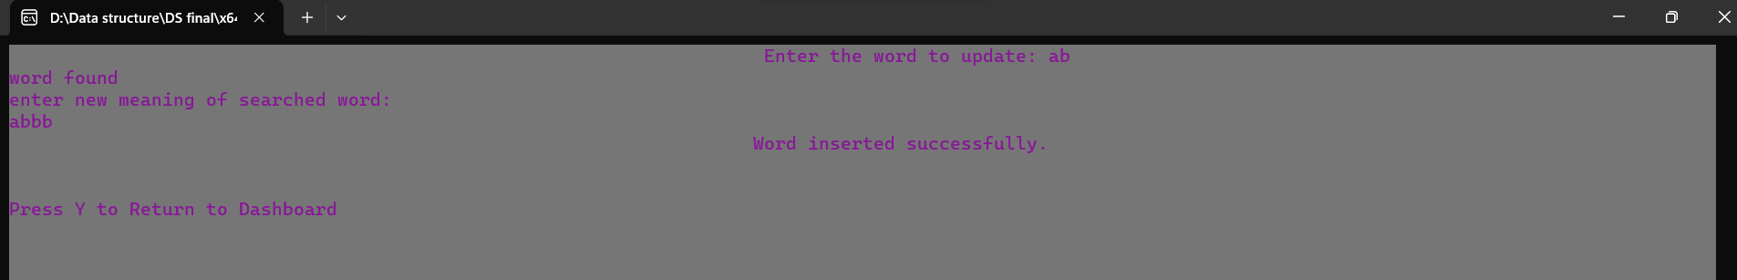

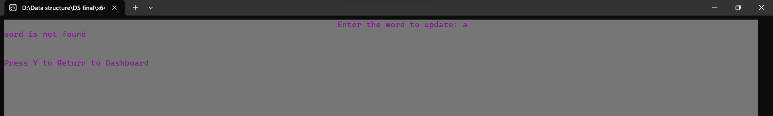

Exit program:

